**Name: VISHNU SADASIVAN**

**Roll No: 52**

**Batch: B**

**Date: 08-04-2022**

**ADVANCED DBMS LAB**

**Experiment No.: 2**

**Aim**

To familiarize with selecting data from single table.

**Questions:**

Using the lab cycle 01 database, perform the following queries.

1. List all data from table deposit
2. List all data from borrow
3. List all data from customer
4. List all data from branch
5. Give account no and amount of deposite
6. Give customer name and account no of depositors
7. Give name of customers
8. Give name of branches
9. Give name of borrows
10. Give names of customer living in city Nagpur
11. Give names of depositors having amount greater than 4000
12. Give account date of Anil
13. Give name of all branches located in Bombay
14. Give name of borrower having loan number l205
15. Give names of depositors having account at VRCE
16. Give names of all branched located in city Delhi
17. Give name of the customers who opened account date ‘1-12-96’
18. Give account no and deposit amount of customers having account opened between dates ‘1-12-96’ and ‘1-5-96’
19. Give name of the city where branch KAROLBAGH is located
20. Give details of customer ANIL

**Procedure & Outputs**

1. SELECT*FROM DEPOSITE;

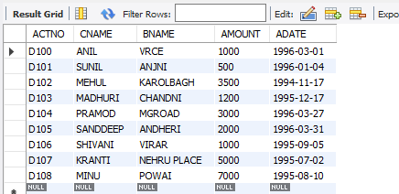

1. SELECT * FROM BORROW;

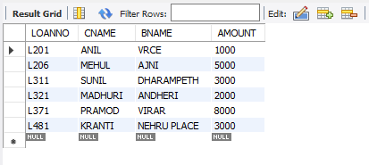

1. SELECT * FROM CUSTOMER;

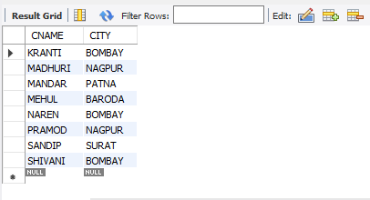

1. SELECT * FROM BRANCH;

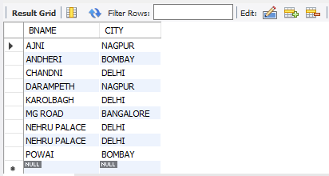

1. SELECT ACTNO,AMOUNT FROM DEPOSITE;

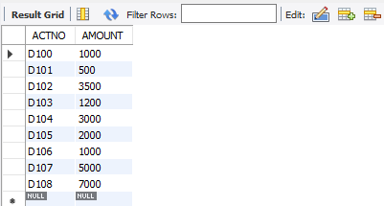

1. SELECT CNAME,ACTNO FROM DEPOSITE;

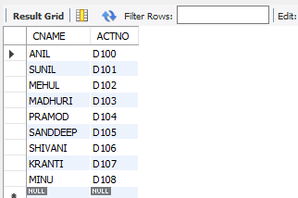

1. SELECT CNAME FROM CUSTOMER;

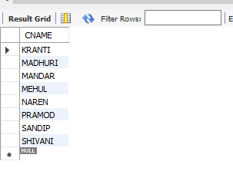

1. SELECT BNAME FROM BRANCH;

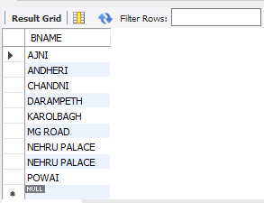

1. SELECT CNAME,BNAME FROM BORROW;

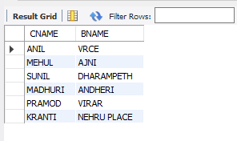

1. SELECT CNAME FROM CUSTOMER WHERE CITY="NAGPUR";

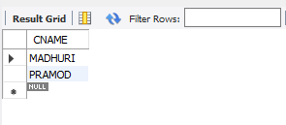

1. SELECT CNAME FROM DEPOSITE WHERE AMOUNT>4000;

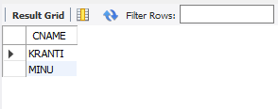

1. SELECT ADATE FROM DEPOSITE WHERE CNAME="ANIL";

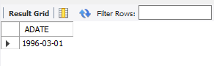

1. SELECT BNAME FROM BRANCH WHERE CITY="BOMBAY";

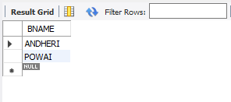

1. SELECT CNAME FROM BORROW WHERE LOANNO="L206";

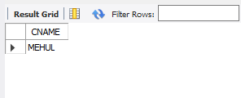

1. SELECT CNAME FROM DEPOSITE WHERE BNAME='VRCE';

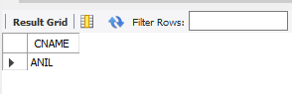

1. SELECT BNAME FROM BRANCH WHERE CITY="DELHI";

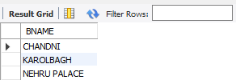

1. SELECT CNAME FROM DEPOSITE WHERE ADATE="1996-03-01";

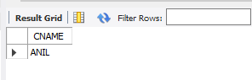

1. SELECT ACTNO,AMOUNT FROM DEPOSITE WHERE ADATE > "1994-11-17" AND ADATE < "1996-03-01";

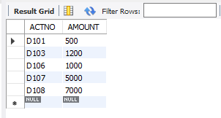

1. SELECT CITY FROM BRANCH WHERE BNAME='KAROLBAGH';

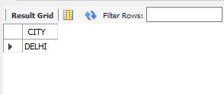

1. SELECT * FROM DEPOSITE JOIN CUSTOMER ON DEPOSITE.CNAME=CUSTOMER.CNAME JOIN BORROW ON BORROW.CNAME=CUSTOMER.CNAME WHERE CUSTOMER.CNAME="MADHURI";

